CodeAlpha Graphic Design Internship:

Task 1: LOGO REDESIGN

ORIGINAL LOGO:


The BookNest logo was redesigned to create a stronger and more memorable brand identity. The open-book icon represents knowledge, learning, and reading, which aligns with the purpose of a bookstore.

VARIATIONS:
Canva link: https://canva.link/ibd4y3rsgar8e0y

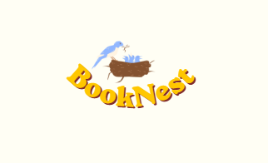
1.

Logic: This design pairs a bird’s nest with feeding chicks to symbolize a bookstore as a nurturing haven where minds are fed with knowledge. The curved, playful lettering forms a protective arc underneath the illustration, reinforcing a cozy and community-driven feel. Meanwhile, the natural brown and soft blue evoke trust and growth, perfectly balanced by the vibrant yellow typography that adds a burst of friendly energy.



Logic: This design utilizes a clean, sketch-inspired open book with flipping pages to dynamically symbolize continuous learning, discovery, and intellectual growth. By embedding the bold, modern typography directly into the illustration, the text and imagery merge seamlessly to establish a cohesive brand story. The stark contrast between the classic black line art and the split blue-and-yellow font beautifully balances professional authority with warm, inviting accessibility.

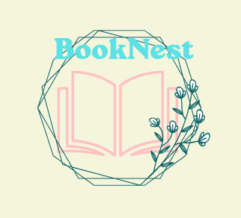
Logic: This design embraces a modern, botanical aesthetic by weaving abstract, angular lines into a unique nest shape that beautifully cradles the open book to symbolize a cozy sanctuary for reading. The combination of the delicate floral accents and the soft pink illustration balances artistic imagination with a sense of growth and discovery. Meanwhile, the bold cyan typography creates a fresh, striking focal point at the top that gives this warm, organic concept a trendy and contemporary edge.

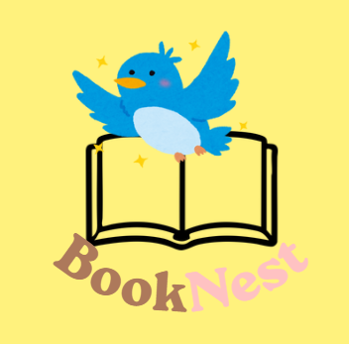
Logic: This design embraces a whimsical, storybook aesthetic by featuring an adorable bluebird perched atop an open book to symbolize the joy of reading and taking flight through imagination. The surrounding gold sparkles add a sense of magic and curiosity, perfectly matching the welcoming, youthful energy of the character. Underneath, the curved typography splits the brand name into grounded brown and playful pink tones, beautifully reflecting a balanced blend of warmth, comfort, and creative fun.

TASK 2: TYPOGRAPHY PRACTICE

Canva link:https://canva.link/kabcs07sa195lhi

Made on Canva:
